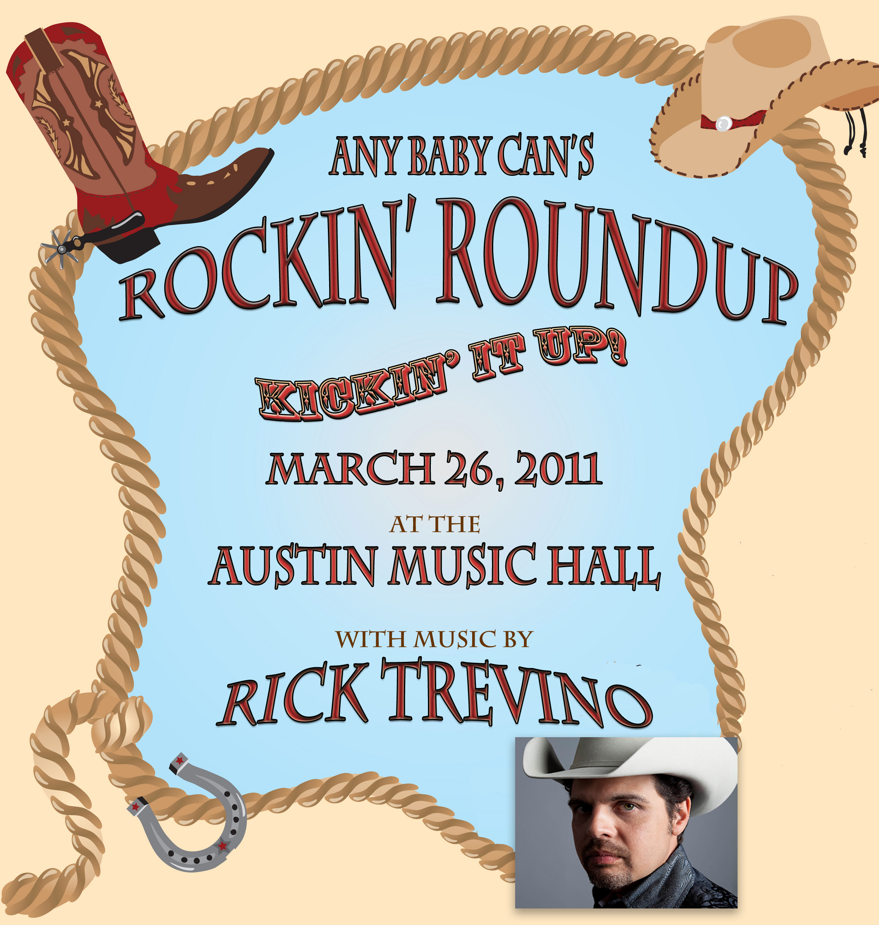

Rockin’ Roundup – now in its 14th year, is the single annual fundraising gala for Any Baby Can, a non-profit organization that brings help and hope to over 6,000 of the youngest, sickest and poorest children and their families in our community. Each year, our guests enjoy a fabulous dinner, games and silent auction. Folks come back year after year to spend the evening with friends and check out what’s new at Any Baby Can!

The event offers premium brand recognition with some of our area’s top philanthropists and corporate executives. We expect a record crowd this year as we hold the event at Austin Music Hall for the first time. In addition to showcasing your products, your company name will be featured on signage at the auction and in the program.

To contribute to the Rockin’ Round-up Silent Auction, please complete the following information by March 15, 2010 and email or mail to:

Marie Felan, Chief Development Officer
1121 E 7th Street
Austin, Texas 78702
(512) 334-4452
marief@abcaus.org
Silent Auction Form
Please complete all information

Contact Name:

Company:
Email:

Address:

Phone:________________________________ Fax

Item Description:

Value: $___________________ (required for IRS purposes)

Any Baby Can of Austin, Inc DBA Any Baby Can Child and Family Resource Center is a 501 (C) 3 organization, Tax ID # 74-2684335.

We appreciate your support.

